UK Railway Power BI Dashboard

DEPI Project - Documentation Team 2

1. Introduction:
This project focuses on analyzing the operational performance of the UK railway system. By utilizing Power BI's powerful data visualization and business intelligence capabilities, the project aims to deliver actionable insights into journey times, delays, and overall service performance across the UK railway network.

2. Data Sources:
The data was sourced from DEPI Instructor.

3. Objective:
- To assess the punctuality and reliability of UK railway services.
- To identify patterns and trends in delays and cancellations.
- To provide insights into factors impacting journey times.
- To develop a dashboard for monitoring railway operations.

4. Data Model & Relationships:
The data model consists of the following tables:
- Railway Data: Contains detailed records of journey times, delays, cancellations, and operational statuses.
- Date Table: Facilitates time-based analysis.
Relationships were created based on common field, Date of Ticket purchase, allowing for comprehensive analysis across various dimensions.

5. Dashboard/Report Structure:
-Revenue Analysis- Displays Revenue Date of Journey, Ticket types, Ticket class etc.
-Trip Analysis: Displays key metrics such as on-time performance and delay statistics across different routes and time periods.
-Trend Analysis Charts: Line charts showing trends in delays and cancellations over time, segmented by month and year.
-Filterable Reports: Allows users to filter data by date, route, and station to drill down into specific performance metrics.

6. Key Metrics & KPIs:
- Revenue: Total Sales generated from Transactions.
- On-time Performance: Percentage of trains arriving on time.
- Total Journeys: Number of completed railway journeys.
- Top Routes: Best and worst performing routes based on tickets sold & Revenue.

7. Analysis & Insights:
1.Punctuality Analysis:
- Identified that a significant percentage of trains arrived on time, with variations observed across different times of the day and days of the week.
- Weekday mornings and evenings experienced the highest delays, suggesting peak hours impact punctuality.
2.Delay Patterns:
- Certain routes consistently experienced higher delays, highlighting areas that need operational improvements.
- Seasonal variations showed that winter months had increased delays due to adverse weather conditions.
3.Cancellation Analysis:
- The analysis revealed that cancellations were more frequent on specific routes and during particular times, indicating potential areas for infrastructure or scheduling improvements.
4.Journey Time Insights:
- Factors such as route length, station stops, and peak travel times were analyzed to understand their impact on journey times.
- Identified the longest and shortest average journey times, providing insights for route optimization.

6. Conclusion:
The UK National Rail Challenge project provides valuable insights into the performance and reliability of railway services. The interactive dashboards and visualizations enable stakeholders to make informed decisions aimed at improving operational efficiency and passenger satisfaction. By identifying trends and key performance indicators, the project helps in optimizing railway operations, reducing delays, and enhancing overall service quality.

Project Planning

✅ Phase 1: Define Objectives
- Goal: Analyze UK National Rail performance, passenger trends, and revenue.
- Key Questions:
  - What KPIs do we need? (e.g., passenger numbers, punctuality, revenue)
  - Who is the audience? (management, operations, public)
  - What insights should the dashboard deliver? (trend analysis, regional breakdown, forecasting)

✅ Phase 2: Data Collection
- Sources:
  - UK National Rail open data (performance, schedules, ticket sales)
  - Government transport datasets
  - External sources (weather, events for correlation)
- Tasks:
  - Identify APIs or CSV downloads
  - Validate data quality and completeness
  - Schedule refresh frequency (daily, weekly)

✅ Phase 3: Data Modeling
- Steps:
  - Create a data model in Power BI or Fabric Lakehouse
  - Define relationships (stations, routes, time periods)
  - Apply transformations (cleaning, normalization)
  - Add calculated columns and measures (e.g., revenue per passenger, delay percentage)

✅ Phase 4: Dashboard Design
- Visuals:
  - Map visualization for station performance
  - Trend charts for passenger numbers and delays
  - KPIs cards for revenue, punctuality
  - Filters (region, time period, train operator)
- UX Considerations:
  - Mobile-friendly layout
  - Clear color coding for delays vs on-time performance

✅ Phase 5: Implementation
- Build in Power BI Desktop or Microsoft Fabric
- Connect to data sources (Direct Query or Import)
- Apply DAX measures for KPIs
- Test interactivity and performance

✅ Phase 6: Deployment & Monitoring
- Publish to Power BI Service
- Set up scheduled refresh
- Implement Row-Level Security if needed
- Gather feedback and iterate

✅ Phase 7: Advanced Features (Optional)
- Predictive analytics (forecast passenger demand)
- AI insights (anomaly detection)
- Integration with Power Automate for alerts

Gantt chart for your project plan

✅ Timeline:
- Define Objectives: Oct 1 – Oct 4
- Data Collection: Oct 5 – Oct 13
- Data Modeling: Oct 14 – Oct 22
- Dashboard Design: Oct 23 – Oct 31
- Implementation: Nov 1 – Nov 9
- Deployment & Monitoring: Nov 10 – Nov 13
- Advanced Features: Nov 14 – Nov 30
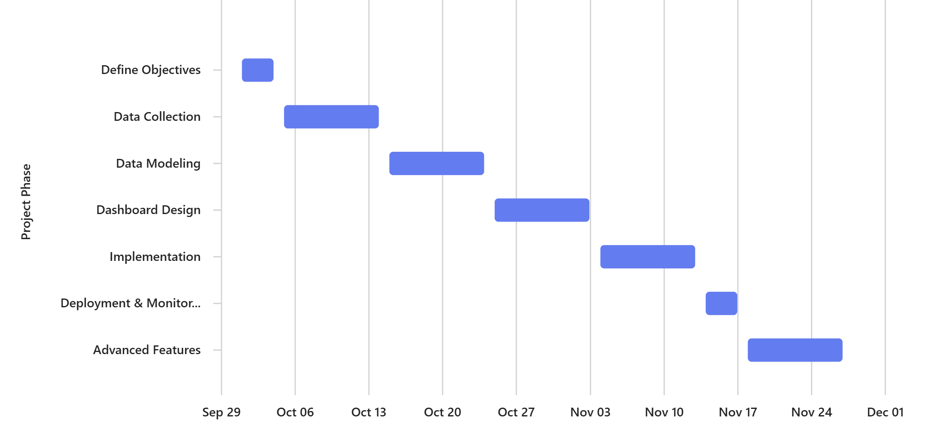

Stakeholder Analysis for your UK National Rail Analysis dashboard project:

✅ 1. Identify Stakeholders
Stakeholder | Role | Interest | Influence
Project Sponsor | Provides funding & strategic direction | High (wants ROI & insights) | High
Data Team | Collects & cleans data | High (data quality) | Medium
BI Developers | Build dashboard & models | High (technical execution) | Medium
End Users (Ops Team) | Use dashboard for decisions | High (usability & accuracy) | Low
IT Department | Infrastructure & security | Medium | Medium
Regulatory Bodies | Compliance with data standards | Medium | High
Management | Consumes reports for strategy | High | High

✅ 2. Stakeholder Power-Interest Grid
- High Power, High Interest: Project Sponsor, Management → Keep closely engaged
- High Power, Low Interest: Regulatory Bodies → Keep satisfied
- Low Power, High Interest: End Users → Keep informed
- Low Power, Low Interest: External vendors → Monitor only

✅ 3. Communication Plan
Stakeholder | Communication Method | Frequency
Project Sponsor | Executive summary report | Bi-weekly
Data Team | Technical meetings | Weekly
BI Developers | Daily stand-ups | Daily
End Users | Training sessions | At launch
Management | Dashboard demos | Monthly

